1-Área del cuadrado ejercicio #1

<https://lucid.app/lucidchart/5c0d9697-93ce-4e5e-9874-0c35386364d8/edit?viewport_loc=269%2C-560%2C1062%2C508%2C0_0&invitationId=inv_e03701c7-9cb4-4a4f-b8d7-de030a11635c>

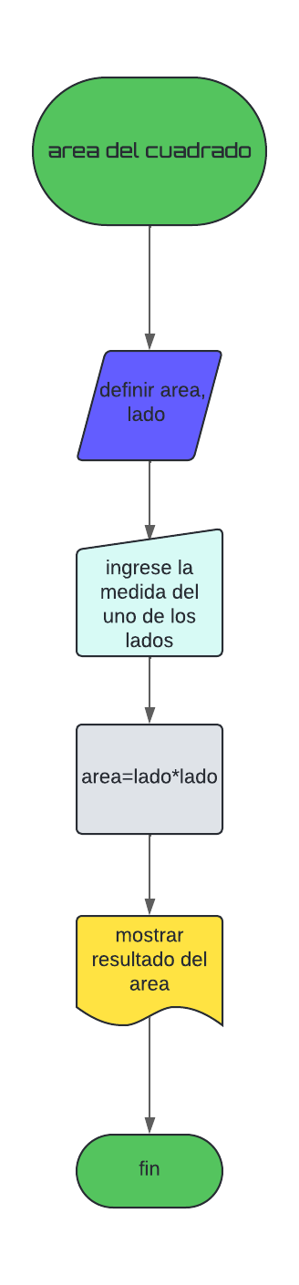

2-area del trapecio, ejercicio#3

<https://lucid.app/lucidchart/68e07b08-1319-41a6-8d00-c496e6df1afb/edit?viewport_loc=-772%2C-483%2C2939%2C1406%2C0_0&invitationId=inv_826ff1f6-89d0-4052-88a2-cf277aea7c9d>

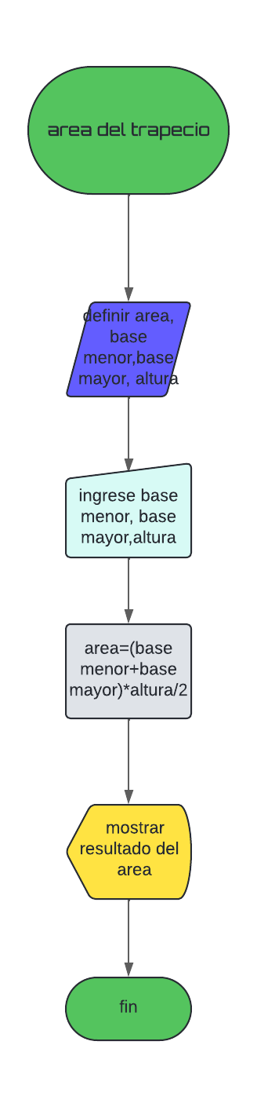

3-Dando un valor A nos diga si es par o impar ejercicio #7

<https://lucid.app/lucidchart/e348d157-7abe-4a53-9a8b-cd8da07ff6ab/edit?viewport_loc=-64%2C97%2C1416%2C677%2C0_0&invitationId=inv_272ce050-f9f7-4cdf-932f-e4078256250e>

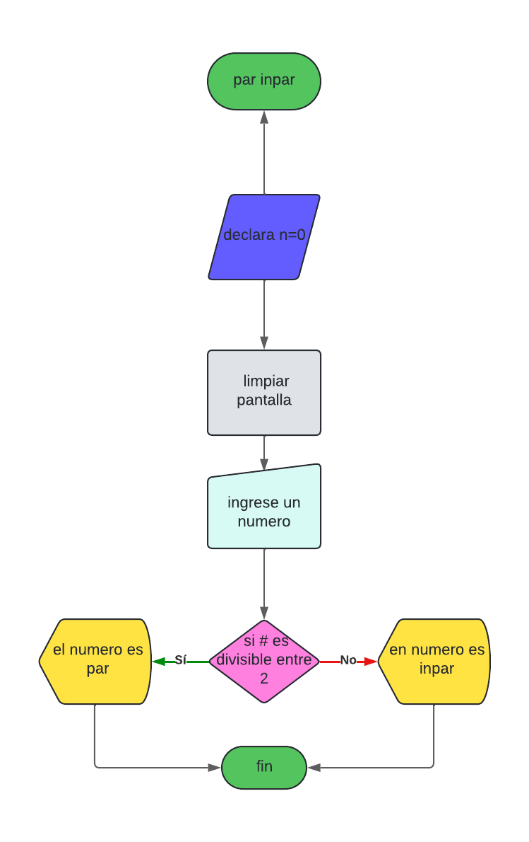

4 precio1 y precio ejercicio#10

<https://lucid.app/lucidchart/ca35e3c3-503f-40ed-a842-9bdb5c0d7997/edit?viewport_loc=-1920%2C111%2C3478%2C1664%2C0_0&invitationId=inv_433edf65-c909-4e10-a03b-7c6d13cd07ab>

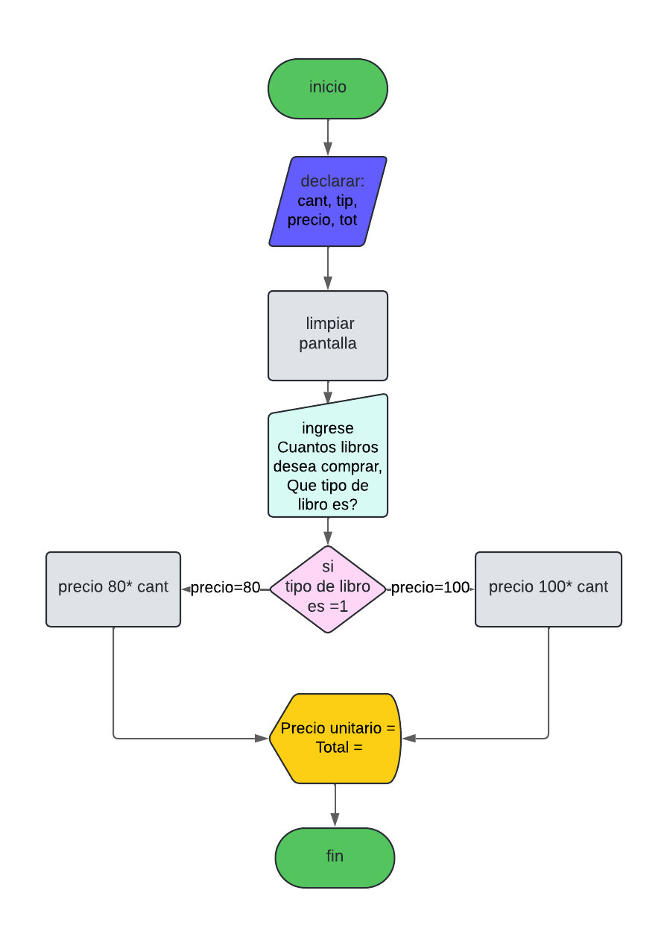

5-Raíz cuadrada de un número ejercio#13

<https://lucid.app/lucidchart/9da0790f-f2f2-4511-afd9-0557a9bb362b/edit?view_items=8ZOHDfOtXZ4R%2CBZOH3DbAmU-c%2ChXOH2PQc50Vo%2CSXOH31THi2ck%2CR1OHdF22eb6~%2Ch5OH6_NwzVqd%2C75OH4Uc6jGUT%2CjZOH5h6g6ulW%2CFXOHVuDzVeua%2CWZOHcncryFCD%2C70OHeCz66ppa%2Cl4OHc9IrtSOo%2C65OHbX2_VE-r&invitationId=inv_6c07a8ce-b657-4449-99d6-2e3b2a790298>

